Student Email and Identifier Validation
1. Problem Statement
Write a Python program to validate a student's email and registration identifier.
2. Assumptions
- Email must contain @ and ..
- @ must appear before the last dot.
- Registration ID must contain 3 letters followed by 7 digits.
3. Algorithm
- Start.
- Enter student email and registration ID.
- Check email format.
- Display valid or invalid email.
- Check registration ID length and characters.
- Display valid or invalid identifier.
- Stop.
4. Flowchart
Start

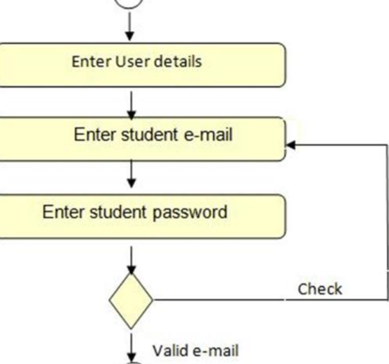
stop

5. Pseudocode
START
INPUT email
INPUT reg_id

IF email contains @ and .
AND @ comes before last dot
DISPLAY "Email Valid"
ELSE
DISPLAY "Email Invalid"
END IF

IF length(reg_id) = 10
AND first 3 characters are alphabets
AND remaining 7 characters are digits
DISPLAY "Identifier Valid"
ELSE
DISPLAY "Identifier Invalid"
END IF

STOP
6. Output
Enter student email: abc@gmail.com
Enter registration identifier: CSE2026001

Email format: Valid
Registration Identifier: Valid
7. Conclusion
The program validates student email addresses and registration identifiers using Python string operations and conditional statements.

